


NutriLift
A Fitness and Nutrition Tracking Mobile Application with Community and Gamification Features
Academic Year | Module | Assessment Number | Assessment Type
2025/2026 | Project and Professionalism | LO1 | Log Sheet

Full Name: Luja Ratna Manandhar
Student Number: 2407087
Course: BSc. (Hons) Computer Science
University Email: L.R.Manandhar@wlv.ac.uk
Supervisor: Johan Tandukar
Reader: Yogesh Bikram Shah
Date of Submission: February 6,2026
Table of Contents
Log Sheet 1: 2nd November 2025 1
Log Sheet 2: 9th November 2025 2
Log Sheet 3: 17th November 2025 3
Log Sheet 4: 23rd November 2025 4
Log Sheet 5: 30th November 2025 5
Log Sheet 6: 7th December 2025 6
Log Sheet 7: 14th December 2025 7
Log Sheet 8: 21st December 2025 8
Log Sheet 9: 4th January 2026 9
Log Sheet 10: 18th January 2026 10

Log Sheet 1: 2nd November 2025
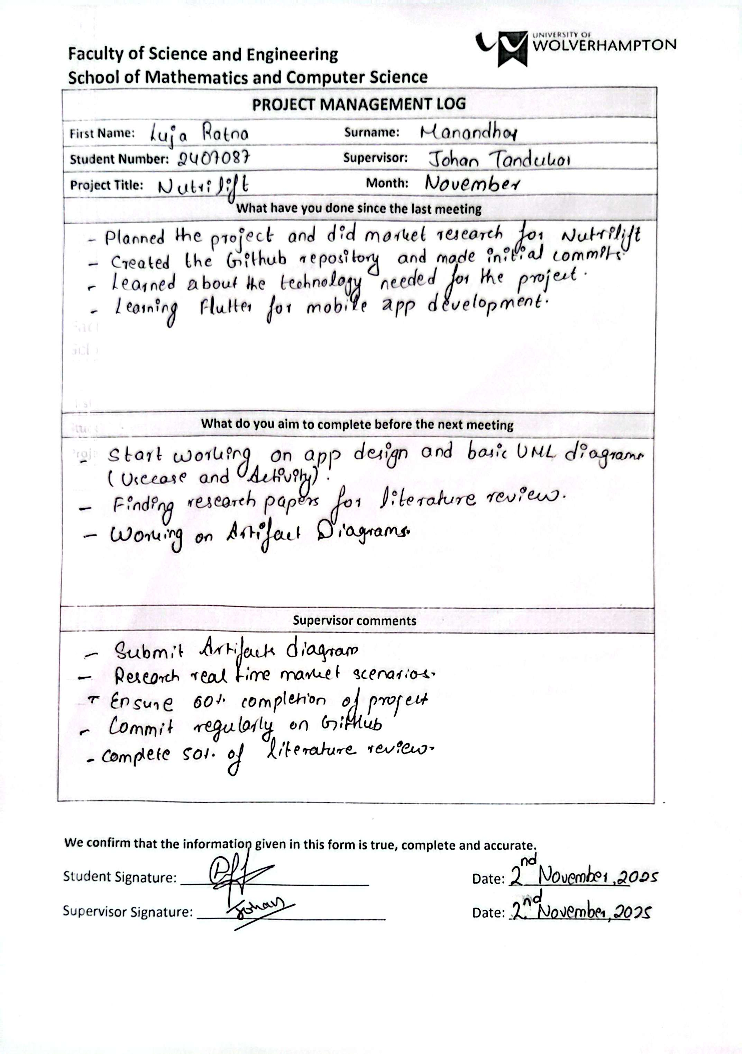

Log Sheet 2: 9th November 2025
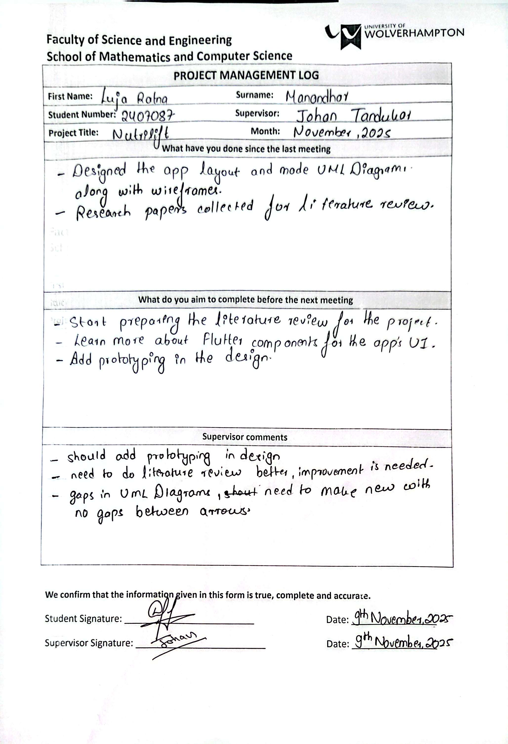

Log Sheet 3: 17th November 2025
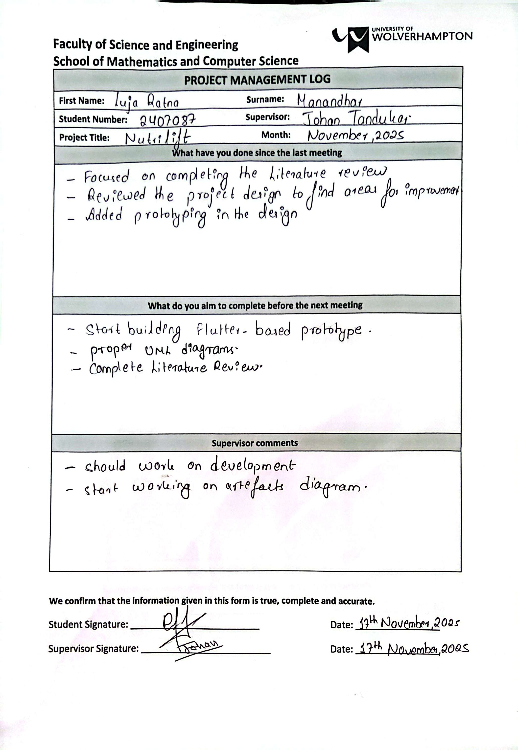

Log Sheet 4: 23rd November 2025
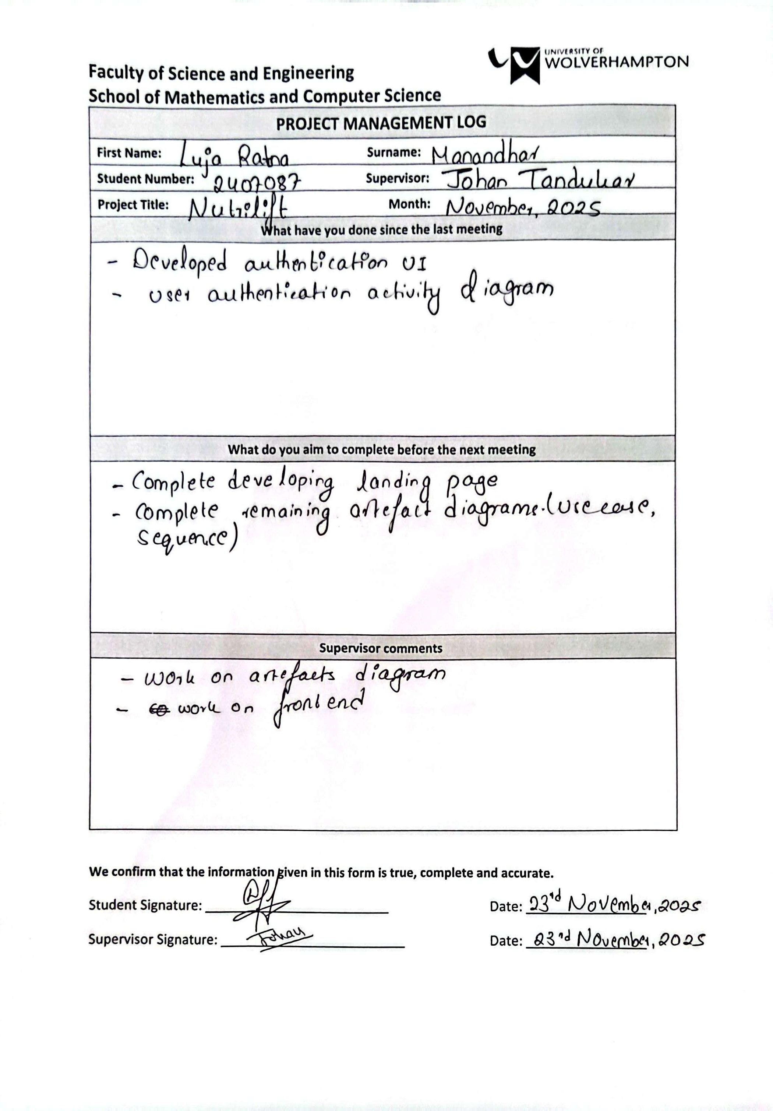

Log Sheet 5: 30th November 2025
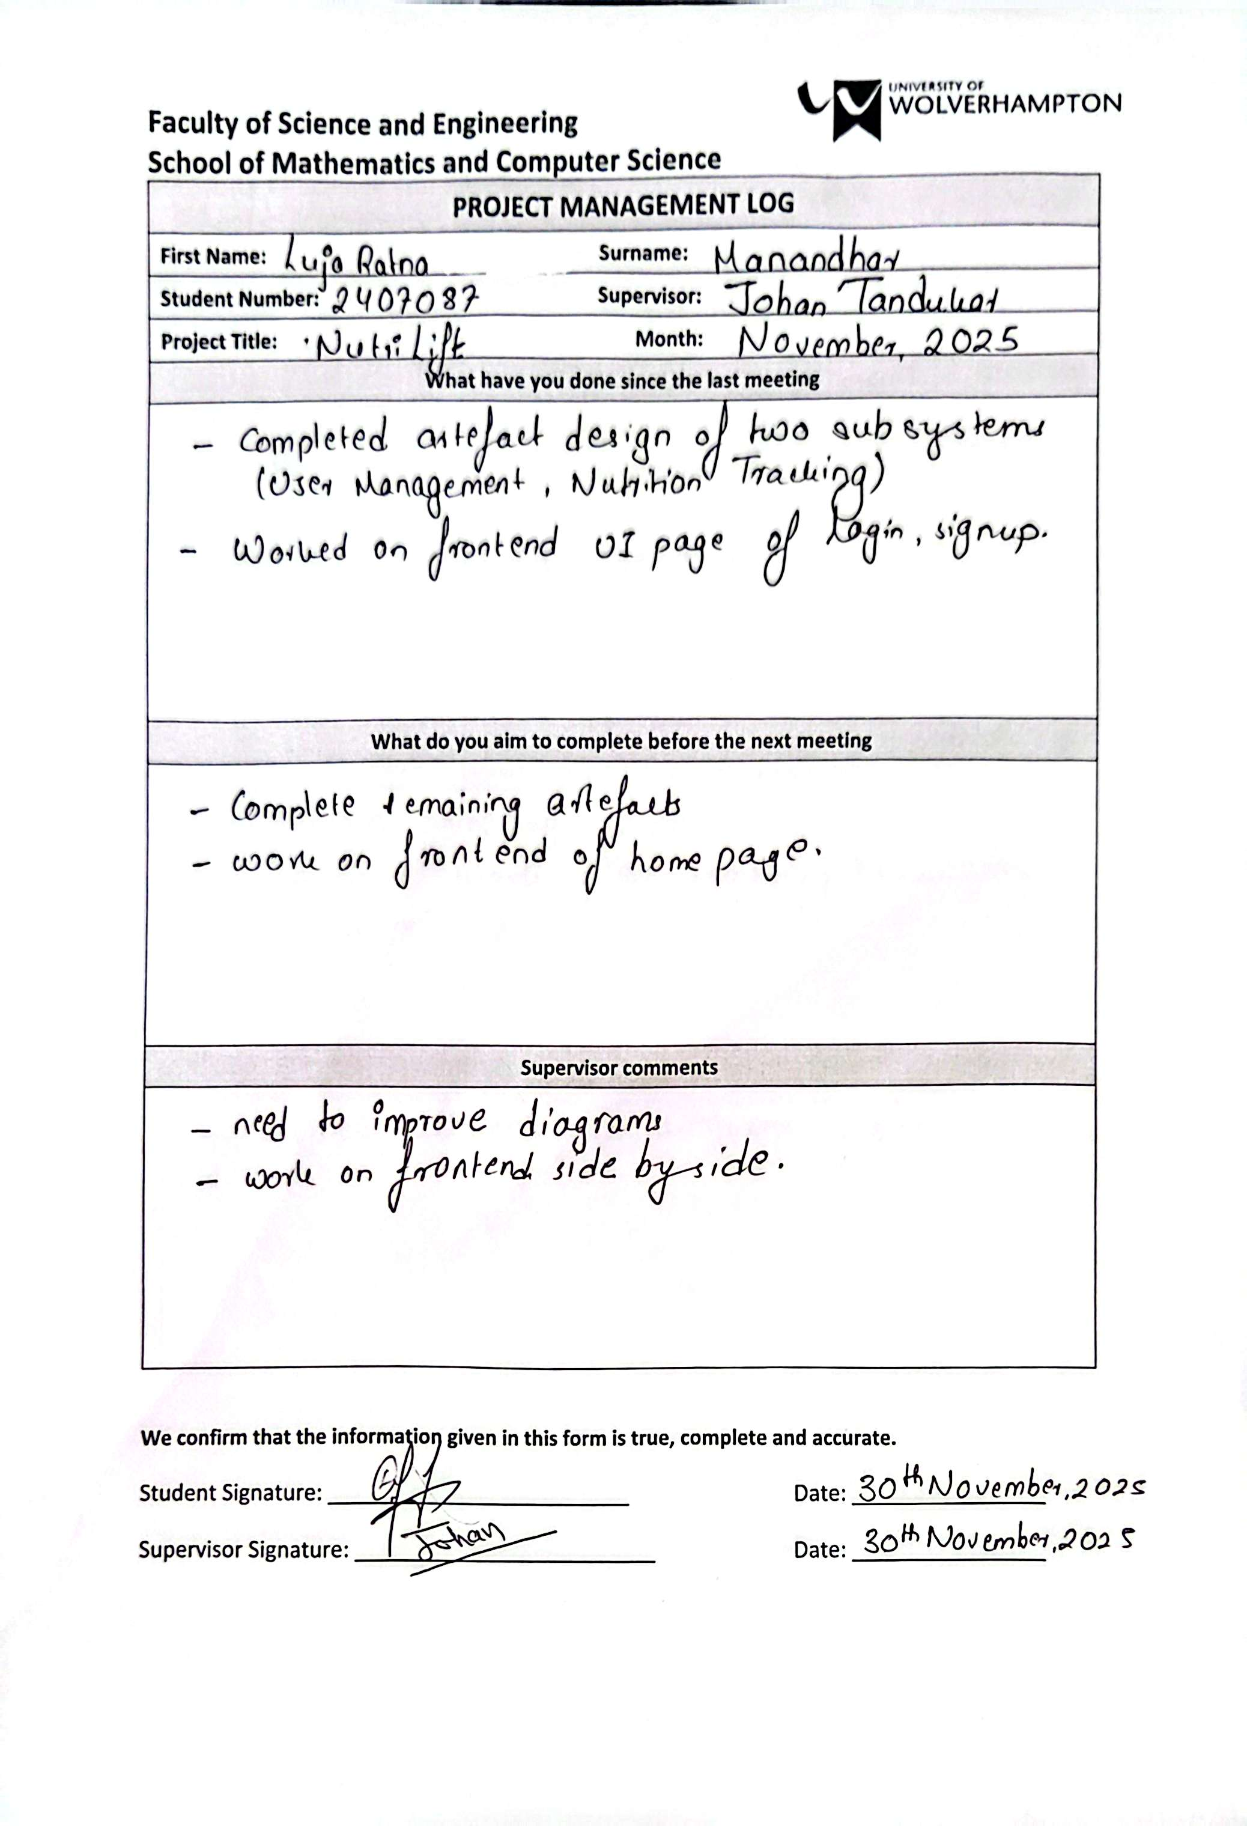

Log Sheet 6: 7th December 2025
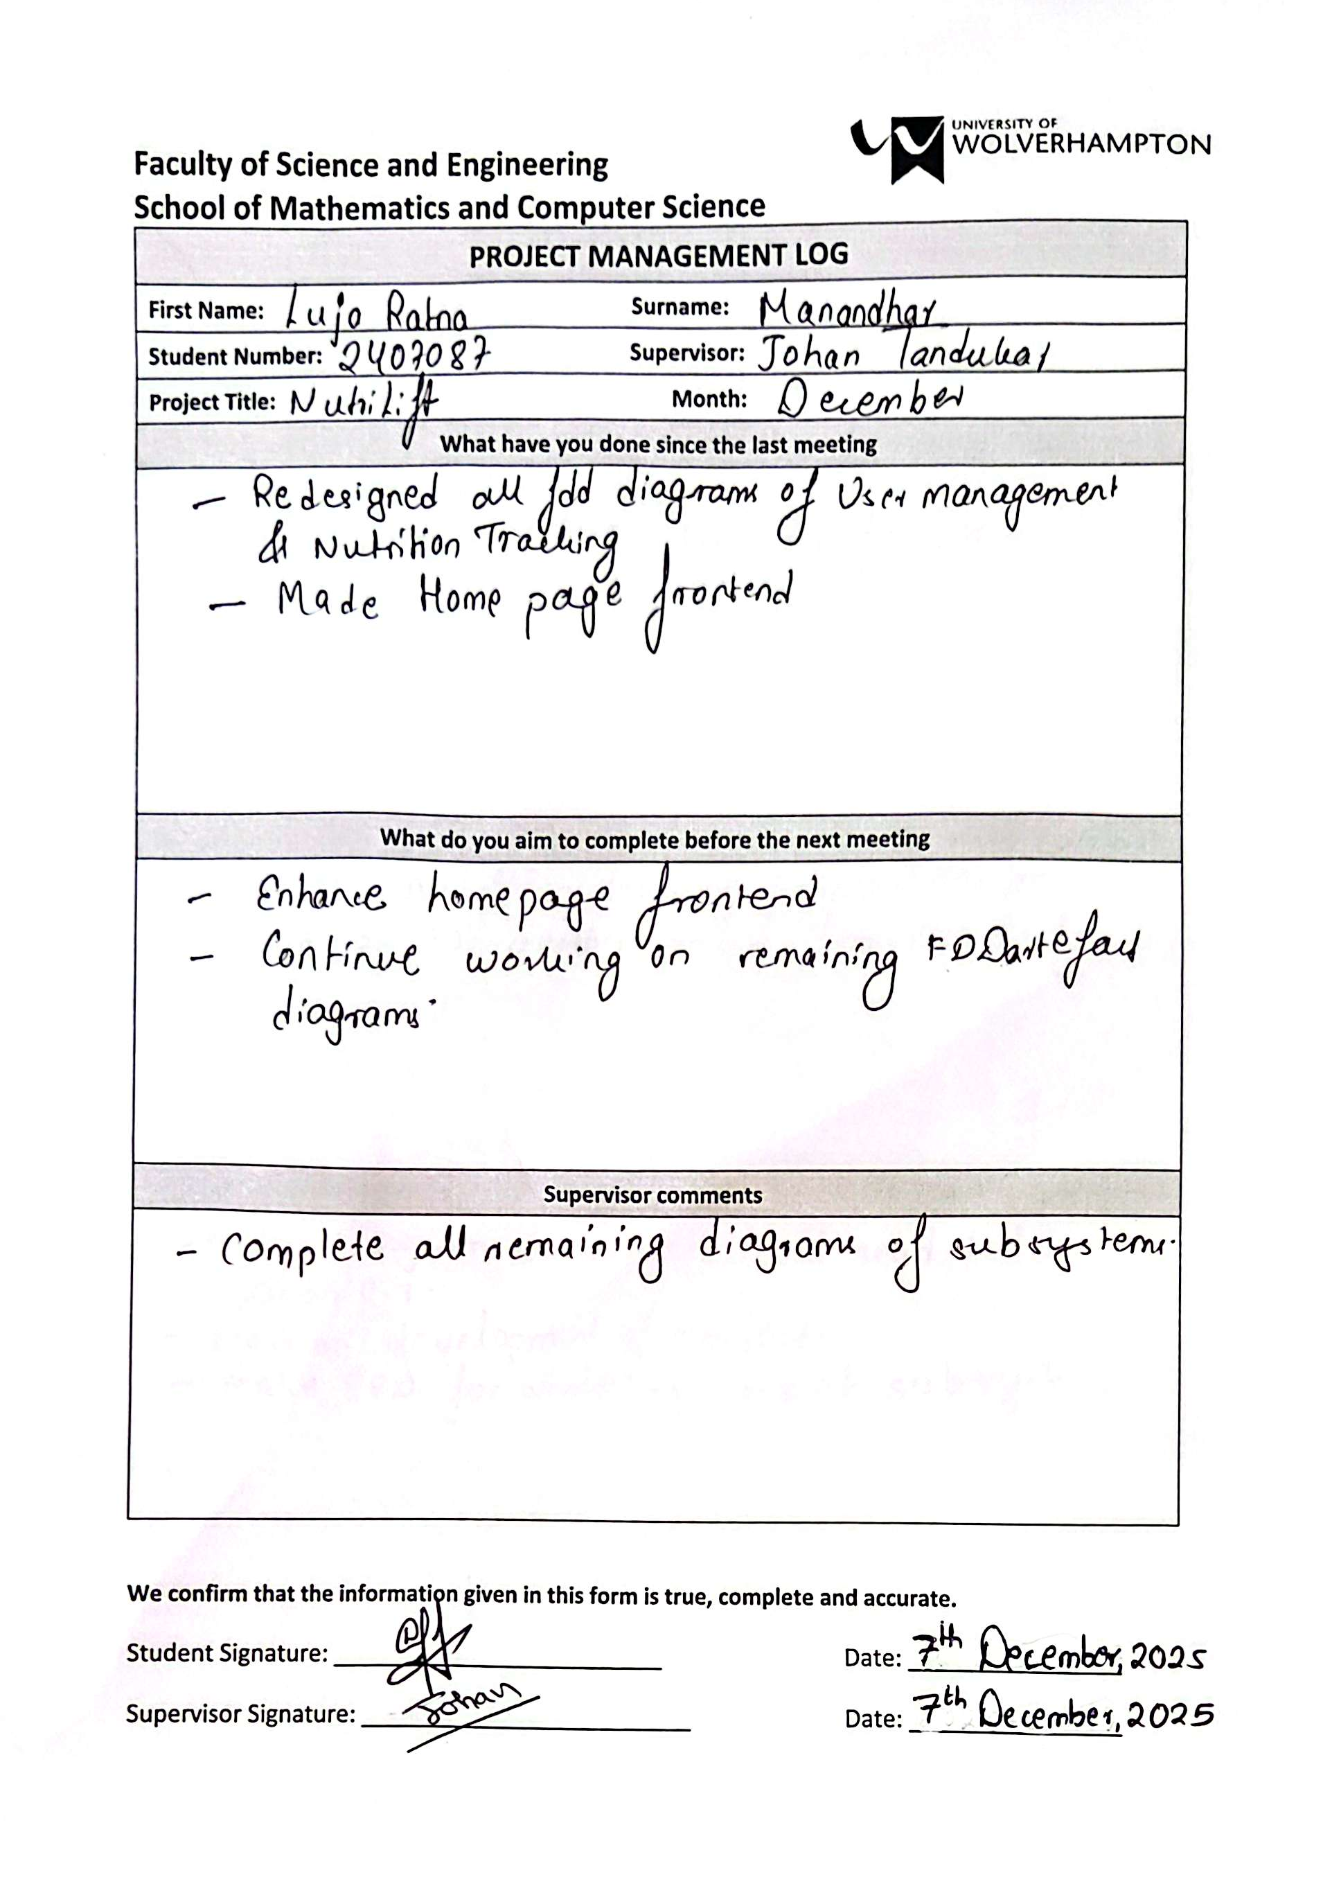

Log Sheet 7: 14th December 2025
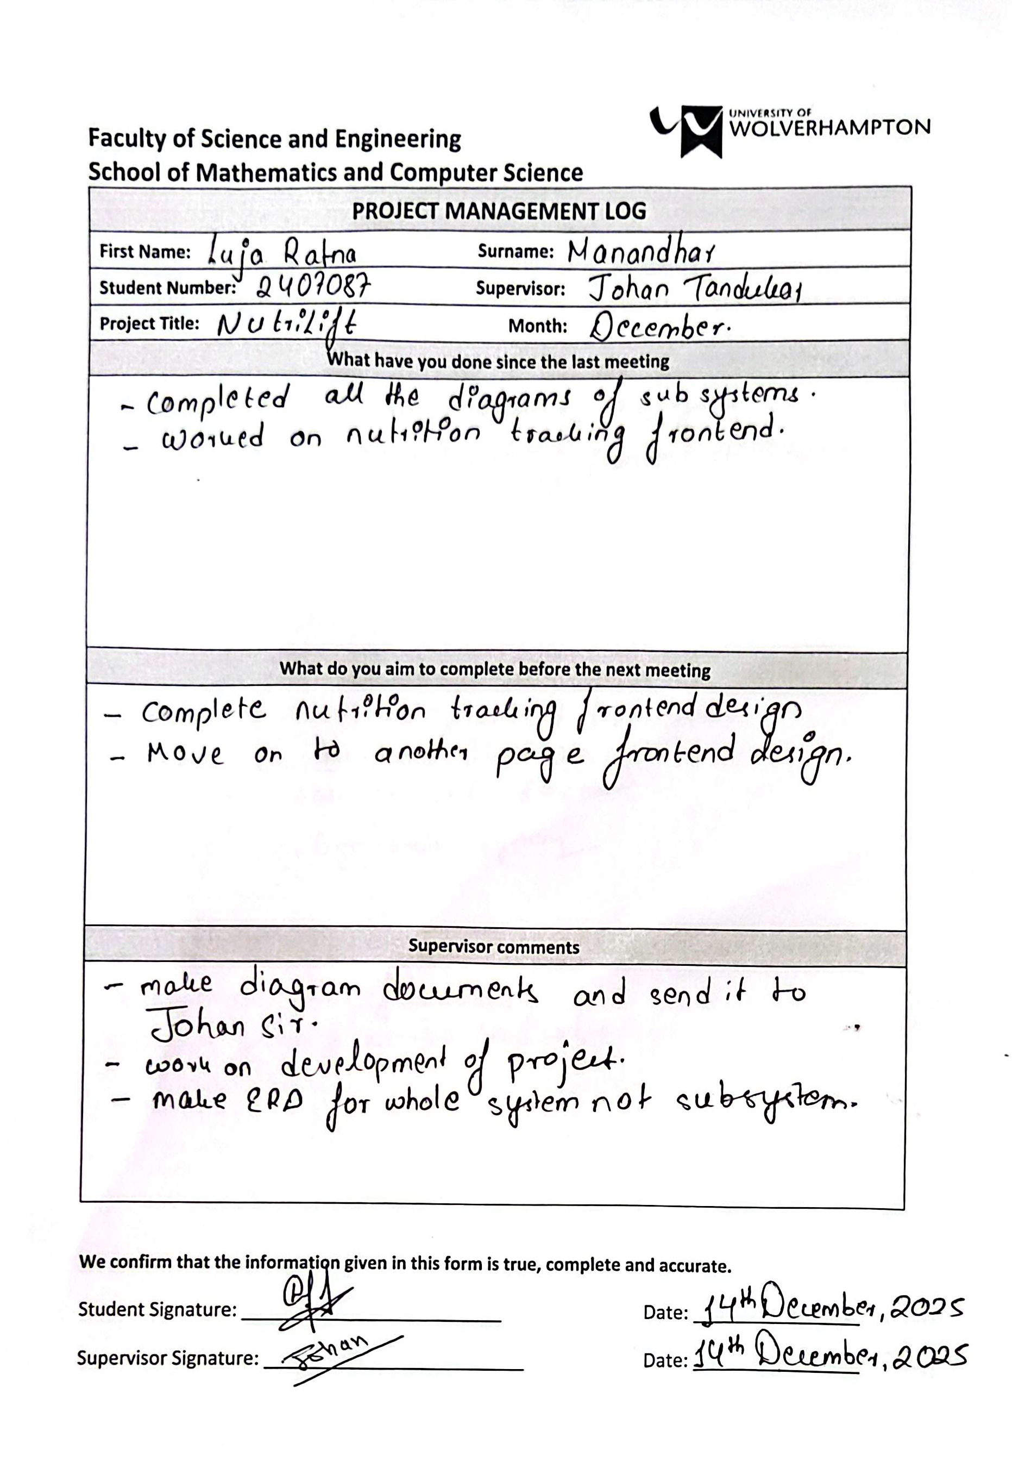

Log Sheet 8: 21st December 2025
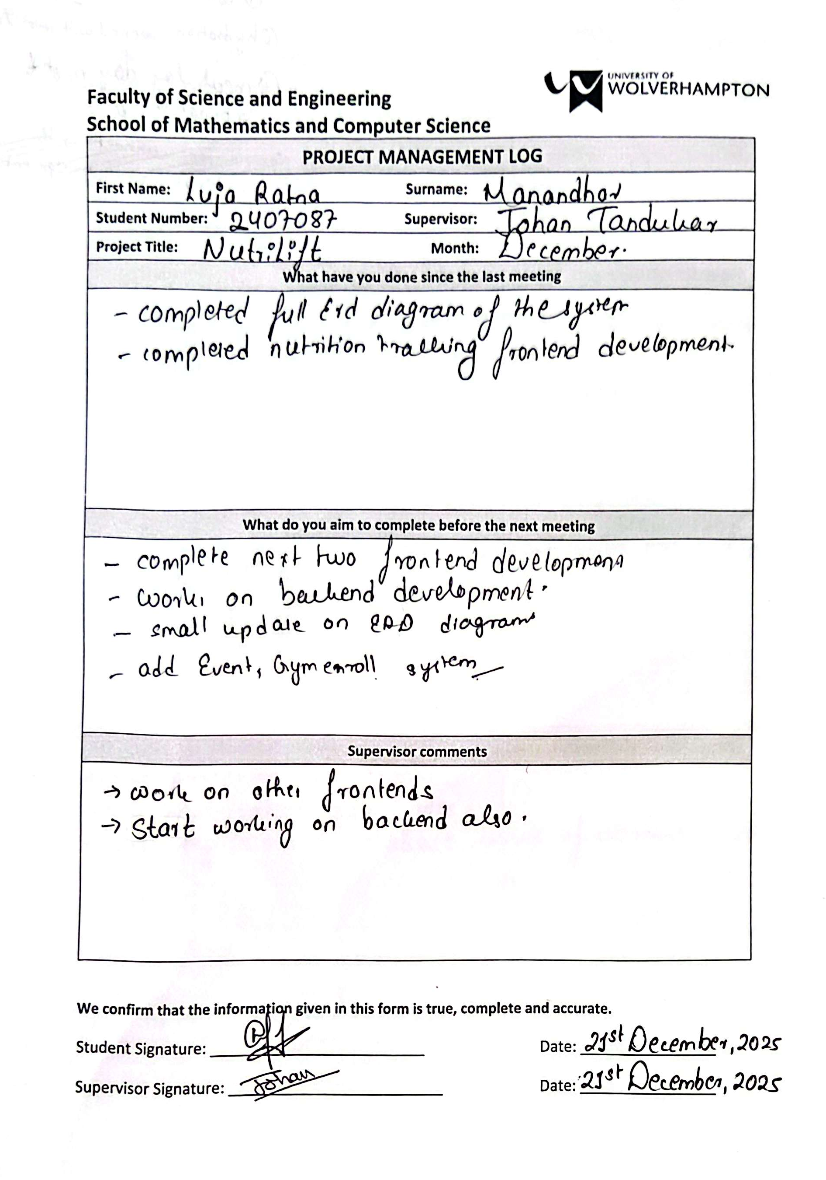

Log Sheet 9: 4th January 2026
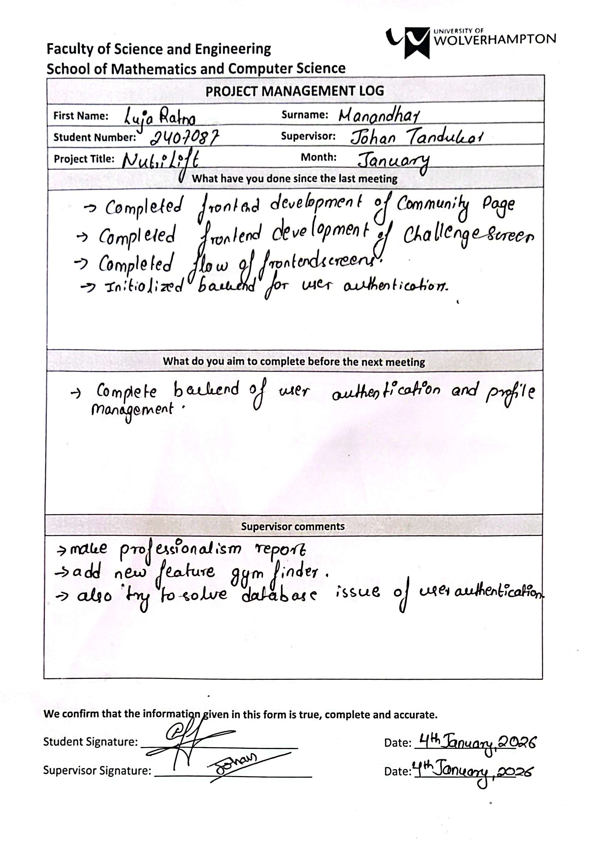

Log Sheet 10: 18th January 2026
